Training course programme

University of WOLVERHAMPTON

TREASURE WATER TRAINING COURSE

"Trans-Regional Environmental Awareness for Sustainable Usage of Water Resources”

26 June – 8 July 2017
MONDAY 26th June 2017
10.00 – 10.30 Welcome from Prof Craig Williams and Dr Kate Tobin. Participants’ short introduction
10.30 – 13.00 Faculty of Science and Engineering,University of Wolverhampton. Applied research and knowledge transfer: visiting and testing research and technology laboratories, innovation centers, study facilities and areas.
13.00 – 14.00 Lunch break
14.00 – 17.00 Faculty of Science and Engineering, University of Wolverhampton. Visit to Built Environment, Information Systems and Learning Technology Research Centre.
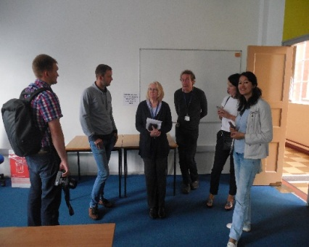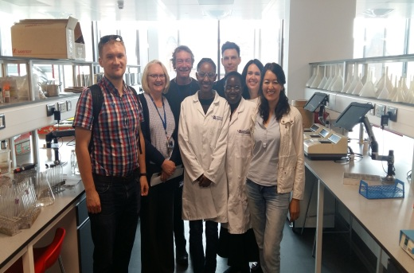

TUESDAY 27thJune 2017
09:00 – 12:00 Moving to the Elan Valley Reservoirs, man-made lakes created from damming the Elan and Claerwen rivers in Mid Wales. Prof Craig Williams and Dr Brian Shiplee.
12:00 – 13:00 Site visit to the Caban Coch dam, lowest of the dams: history, construction, potential capacity. Prof Craig Williams.
13.00 – 14.00 Lunch break.
14.00 – 16.00 Site visit to Pen Y Garreg dam, Craig Goch Reservoir. Water filtration works, environmental impact of reservoirs. Dr Brian Shiplee.
16.00 – 19.00 Return to Wolverhampton
The Craig Goch Reservoir Dam
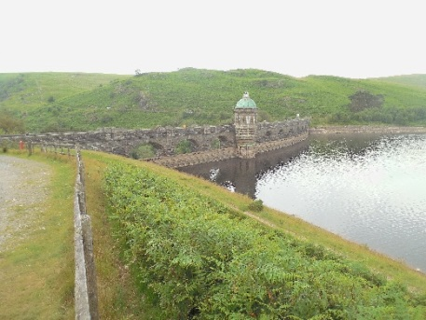

WEDNESDAY 28th June 2017
10.00 – 10.50 Trip to Shrewsburry,EA West Midlands, Hafren House, Welshpool Road.
10:55 Arrive at EA West Midlands, Hafren House & collect visitor passes.
11:00 Welcome and Introduction to Flood Risk Management in the England and UK, Dr Anne Wheeler: Chair of the English Severn and Wye Regional Flood and Coastal Committee.
Dr Anne Wheeler with an opening presentation on “The role of Regional Flood and Coastal Committees (RFCCs) in England”. DrWheeler introduced strategic planningschemes across the whole river catchment to ensure joined up approach to reducing flood risk for communities across England. The speaker addressed an issue of building partnershipsamongwater companies, Internal Drainage Boards, agencies, institutions, landowners and communities as one of the most important aspects of flood risk management into the future.
11:30 Flood Risk Management in Practice, Richard Bentley, Partnership & Strategic Overview Team Leader, Environment Agency West Midlands.
Richard Bentley presented various aspects of the Environment Agency strategies and initiatives for water sector in England. A strategic overview of the management of all sources of flooding and coastal erosionwas submitted by the speaker.
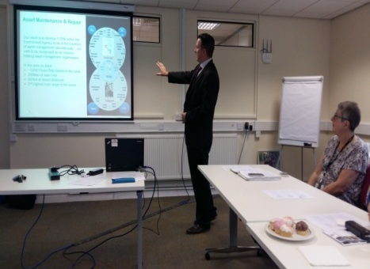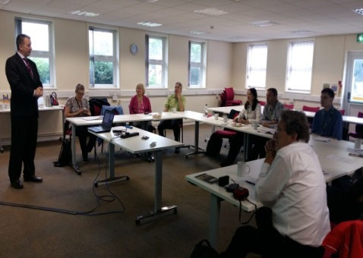

12:10 Travel to Frankwell Car Park. Frankwell is the first area in Shrewsbury where asubstantial number of properties are affected by flooding. Drs Keith Jones and Anne Wheeler.
12:15 Frankwell Flood Alleviation Scheme (FAS), a creative and innovative approach – erecting standardised demountable defences in the event of a flood. Local riverside environment. Observing the construction process. Drs Keith Jones and Anne Wheeler.
12:40 Visit to Lara’s Tower, Shrewsbury Castle located on a hill in the neck of the meander of the River Severn – view Shrewsbury and implications of flooding. Drs Keith Jones and Anne Wheeler.
13:30 Lunch/Free time
15:00 Return to Wolverhampton
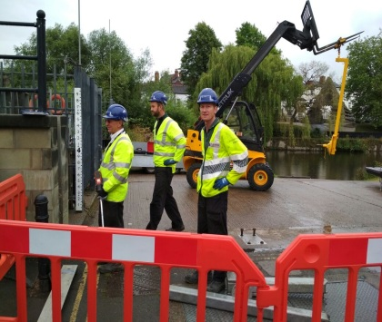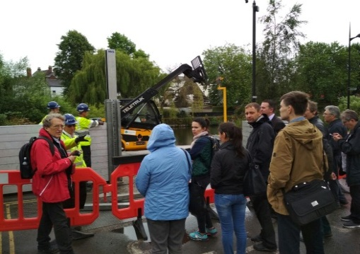

THURSDAY 29th June 2017
10.00 – 12.00 Site visits: West Park with its Lake and the Conservatory,Wolverhampton. The problem of eutrophication as a leading cause of impairment of freshwater ecosystems. Causes, effects and control measures of eutrophication. Prof Craig Williams and Dr Kate Tobin.
12.00 – 12.30 Trip to Severn Trent Water, Canal and River Trust, West Midlands Waterways.
12.30 – 13.30 Lunch Break
13.30 – 15.00 Exploring the Staffordshire and Worcestershire canals, as vital wildlife corridors that provide valuable habitats and places, Canal and River Trust, West Midlands Waterways. Prof Craig Williams and Dr Kate Tobin.
15.00 – 17.00 Bratch Pumping Station and water extraction by Severn Trent. Prof Craig Williams and Dr Kate Tobin.
17:00 Return to Wolverhampton
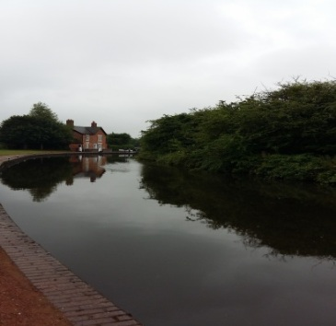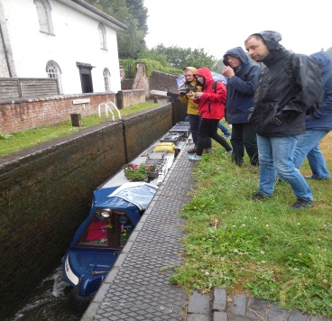

FRIDAY 30th June 2017
10.30 – 11.30 Dr Kate Tobin “Severn Trent Water. Conservation and sustainability information”. Overview of water treatment processes in West Midlands, England: principal objectives, chemical and physical processes involved, basic problems and considerations.
11.30 – 12.30 Meeting with thedean of Faculty of Science and Engineering, University of Wolverhampton – Prof Nazira Karodia. Visiting the Science Education Centre.
12.30 – 13.30 Lunch break
13.30 – 14.30 Dr Brian Shiplee “Fracking& its potential to impact on water resources”. Fracking’s appeal & potential. Stages of the hydraulic fracturing water cycle. Concerns associated with fracking, potentialrisks to the water environment.
14.30 – 15.30 Learning Lab. Presentation on “Distance learning. Online education at the University of Wolverhampton”. Online learning opportunities, innovative educational platforms, research in e-learning.
15.30 – 16.00 Penrith Field Course lead-up
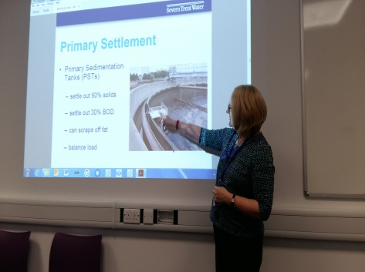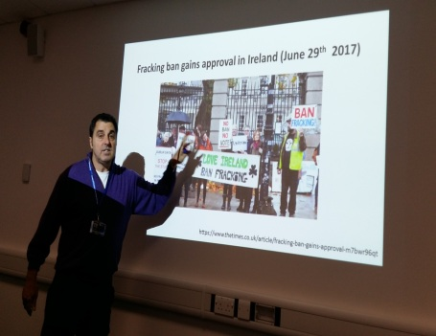

SATURDAY 1st July
Free Day

SUNDAY 2ndJuly 2017
09:00 – 11:00 Moving from Wolverhampton to Brockholes that is a part of a local charity, the Lancashire wildlife trust. Prof Craig Williams, Dr Brian Shiplee.
11:00 – 13:00 Field research of plants, birds, and water management in Brockholes. Prof Craig Williams, Dr Brian Shiplee.
Сereal-herb meadow and broad-leaved wood in Brockholes
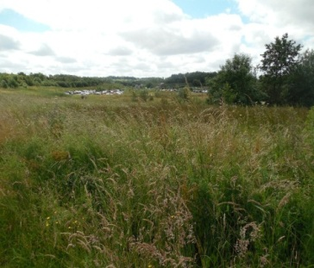
13:00 – 14:00 Lunch break
14:00 – 17:00 Moving from Brockholes to Newton RIGG College two miles westwards Penrith, county of Cumbria.

MONDAY 3rd July 2017
09:00 – 11:00 Water resources: assessment methods and criteria. Visiting Thirlmere Tarn that is a reservoir of fresh water surrounded by 10,000 acres of fells and 2,000 acres of forest. Main water parameters definition, including temperature, pH, conductivity, nitrites, sulphates, etc.Prof Craig Williams, Dr Brian Shiplee.
Field research on the western bank of Thirlmere Tarn
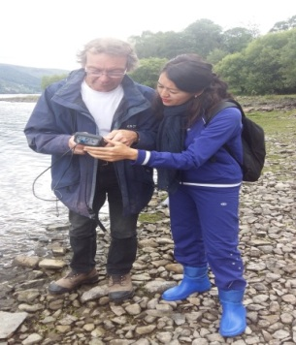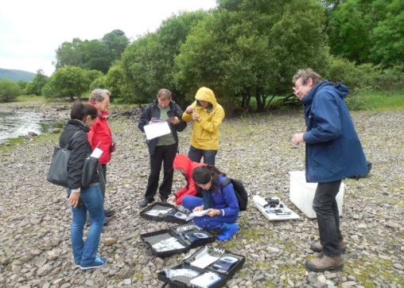
11:00 – 13:00 Climbing the steep slope of the Cumbrian Mountains to Harrop Tarn that is a small lake at the height of 301 m above sea level. The lake is situated 10 km northeast Scafell Pike, which is the highest point of England. Harrop Tarn is connected with Thirlmere Tarn by the brook. Main water parameters definition, including temperature, pH, conductivity, nitrites, sulphates, etc.

Climbing the steep slope of the Cumbrian Mountains to Harrop Tarn
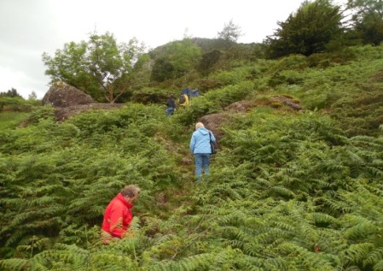
Harrop Tarn. Field research on the eastern bank of Harrop Tarn
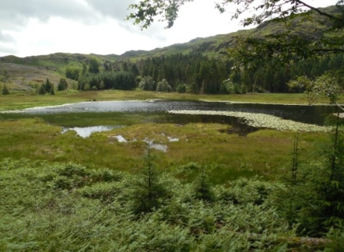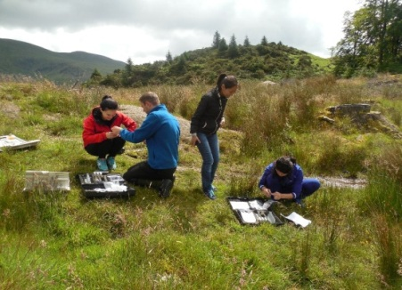
13:00 – 14:00 Lunch break in Ambleside town that is situated on the northern bank of the Windermere
14:00 – 16:00 Visiting the Ullswater that is one of the largest lakes in England. Main water parameters definition, including temperature, pH, conductivity, nitrites, sulphates, etc.
The Ullswater. Field research on the western bank of the Ullswater
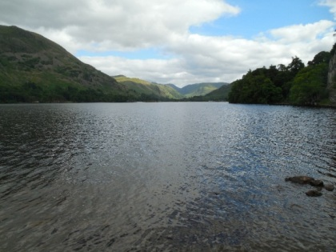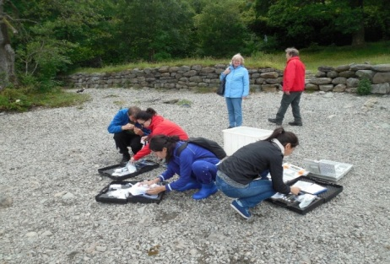
16:00 – 17:00 Moving to Newton RIGG College

TUESDAY 4th July 2017
09:00 – 12:30 Water resources: assessment methods. Visiting the Glenderamackin River near the Trout Beck. Main water parameters definition, including the width (in every metre), depth (in every metre), flow rate and diacharge, temperature, pH, conductivity, nitrites, sulphates, etc. Hydrobionts test. Prof Craig Williams and Dr Brian Shiplee.

The Glenderamackin River
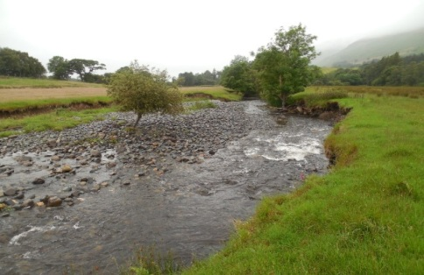

12:30 – 13:30 Lunch break in Newton RIGG College
13:30 – 17:00 Сameral processing of field work results in the University’s laboratory. Results are given in Table 1.
Сameral processing of field work results in University’s laboratory
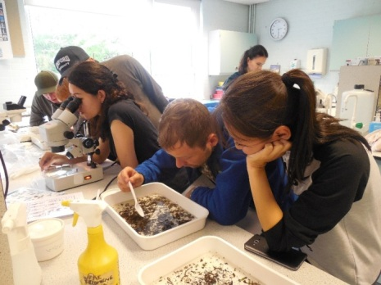

Table 1 – The main parameters of the Glenderamackin River and its tributary
 | Lower | Mid | Upper (above tributary) | Tributary
Stream width, m | 11.1/7.0 | 6.0 | 9.5 | 3.5/5.6
Av. depth, m | 0.14 | 0.62 | 0.15 | 0.122
Substrate type | Cobble/boulder | Gravel/sand | Cobble/pebble | Cobble/boulder
D.O., mg/l | 92.7%/97.4% | 98.2% | 97% | 97.6%
t°C | 11.7 | 11.7 | 13.4 | 13.4
pH | 7.4/7.1
Cond. MS/cm | 43.4 | 40.9 | 40.4 | 70.8
Discharge | 0.75 m³/s |  |  | 0.09 m³/s

WEDNESDAY 5th July 2017
10.00 – 12.00 Trip to St Bees, a villagein the Copeland district of Cumbriaon the Irish Sea coast, the most westerly point of Northern England.
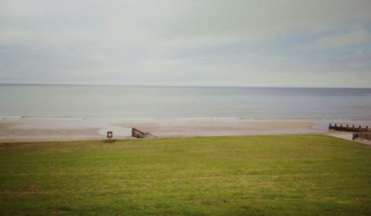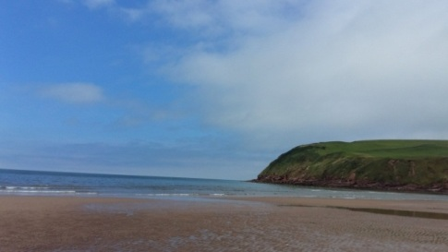
12.00 – 13.30 Shore Ecology at St Bees. Field research of the ways in which organisms are adapted to the environmental conditions they are subjected to, and the ecological niche they occupy in the ecosystem. Prof Craig Williams, Dr Brian Shiplee.
13.30 – 14.30 Lunch Break
14.30 – 16.00 Sea Watch at St Bees. Main water parameters definition, including temperature, pH, conductivity, nitrites etc. Prof Craig Williams
16.00 – 18.00 Moving from the Sea to Newton RIGG College

THURSDAY 6th July 2017
10.00 – 12.00 Methodology for waterbody and watercourse assessment. Establishing indicators for water quality. Site visitto Lake District: Lancashire streams. Prof Craig Williams and Dr Brian Shiplee.
12.00 – 14.30 Trip to the streams flowing down the mountains. Waterbodyassessment: measuring temperature, pH, calcium content, conductivity, O₂.
14.30 – 15.30 Lunch Break
15.30 – 17.00 Establishing indicators for water quality in Upper Duddon river. The investigation of Hardnott and Gaitscale Gill catchment. Prof Craig Williams and Dr Brian Shiplee.
17:00 Return to Newton RIGG College
Table 2 – The basic parameters for the Lancashire streams flowing down the mountains
Name | Temperature  (⁰C) | DO  (%) | Conductivity  (µS) | Calcium concentration  (mg/l) | pH value
Side №1  Three Country stones, very small stream | 16.6 | 53.5 | 22.8 | 9 | 6.5
Side №2 (stream in 300 m below) | 13.8 | 98.8 | 17.7 | 0 | 6.8
Side №3 (500 m below ) | 11.1 | 98.6 | 31.2 | 0 | 7.2
Side №4 (before confluence of 2 streams) | 15.7 | 100.6 | 19.0 | 0 | 6.9
Side №5 (confluence of 2 streams) | 14 | 97.9 | 14.7 | 0 | 6.43
Side №6 (after confluence of 2 streams, 50 m below) | 15.9 | 100.6 | 18.8 | 0 | 6.76
Side №7 (300 m below streams) | 16.2 | 100.8 | 18.4 | 0 | 6.8
Side №8 (before bridge) | 15.9 | 100.6 | 18.8 | 0 | 6.78
Side №9 (after bridge) | 15.8 | 99.8 | 15.2 | 0 | 6.5

Table 3 – The basic parameters for the lakes in the Lake District area
Name | Temperature  (⁰C) | DO  (%) | pH | Conductivity  (µS) | N  (mg/l) | P  (mg/l) | Ammonia  (mg/l)
Ullswater | 15.5 | 109.7 | 8.5 | 41.0 | 2.20 | 0.27 | 0.17
Harrop Tarn | 14.5 | 95 | 6.5 | 15.2 | 2.3 | 0.14 | 0.15
Thirlmere | 15.9 | 114 | 7.5 | 24.6 | 4.3 | 1.25 | 0.05

Field research on the Lancashire streams
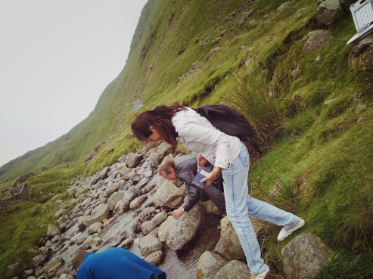

Lancashire streams.Waterbody assessment
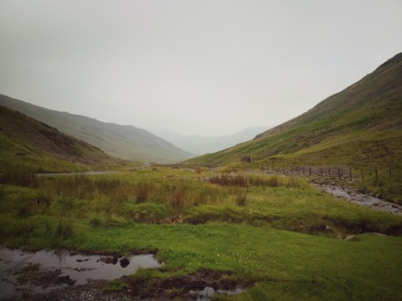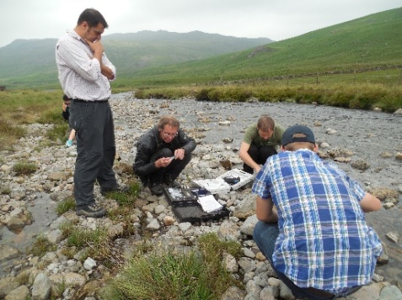

FRIDAY 7th July 2017
09:00 – 12:30 Final day in Newton RIGG College, Penrith. Evaluation of the results: management of rivers, safety assessment, environmental issues discussion. Conclusions & further planning.
12:30 – 13:30 Lunch Break
14:00 – 17:00 Moving from Penrith to Wolverhampton

SATURDAY 8th July 2017
Departure day

